📌 Wireshark
✅ Wireshark is a tool that captures and analyzes network traffic.
✅ It helps you see what data is being sent and received over a network.
✅ You can check network security, troubleshoot issues, and analyze packets.
✅ Wireshark is a network analysis tool that captures network traffic in real time and allows its analysis.
✅ It is used for troubleshooting network issues, checking security, and analyzing packets

📌 Wireshark Installation
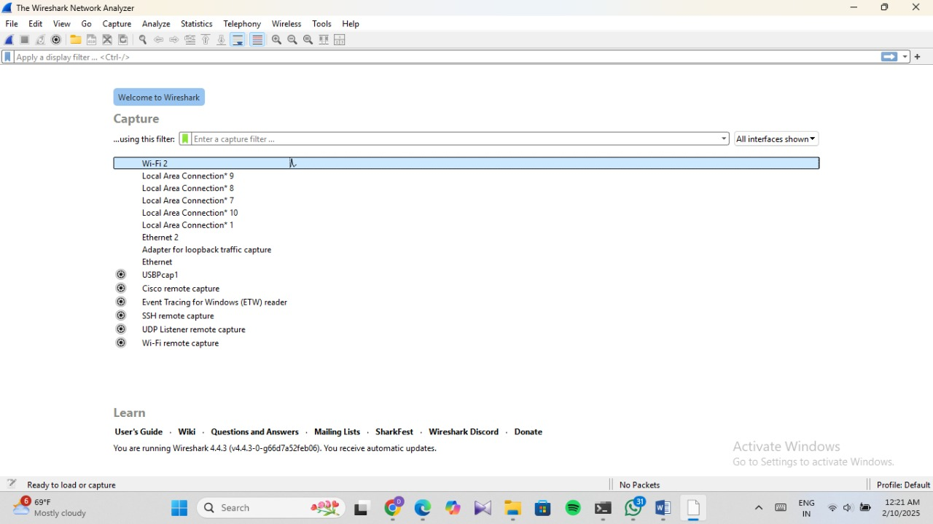

📌 Capture packets while browsing the internet:
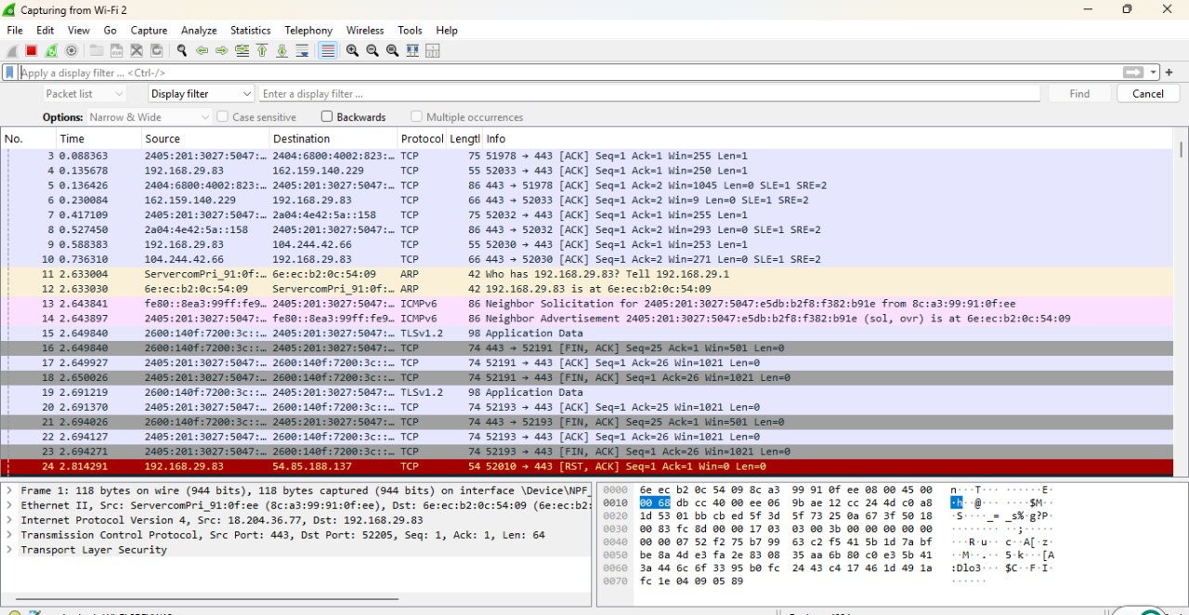
👉 2. Identify HTTP Vs HTTPS traffic:

💡Identify HTTP traffic using http.host:
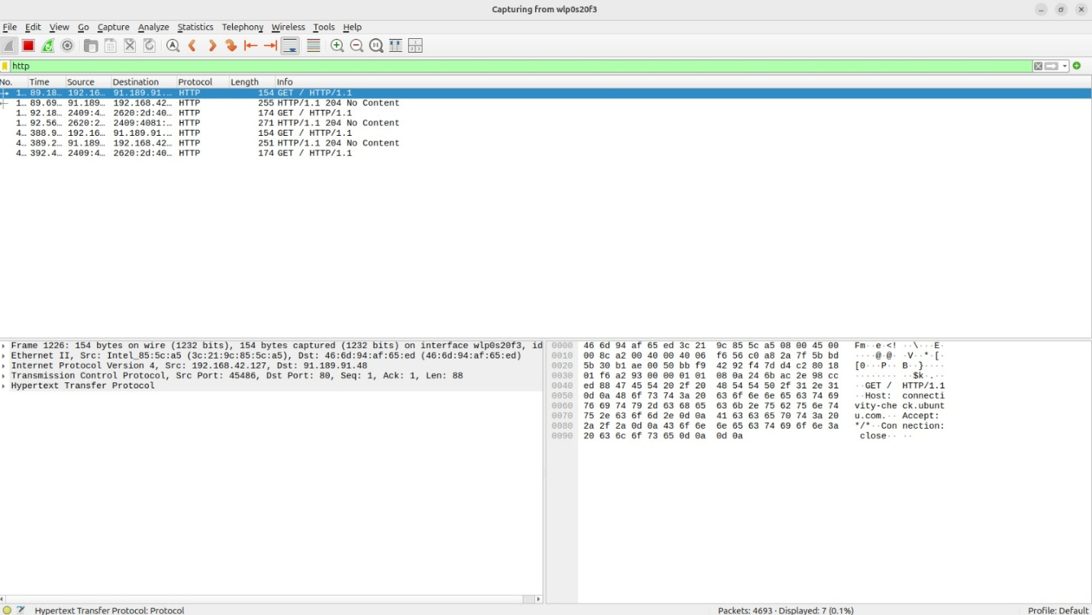
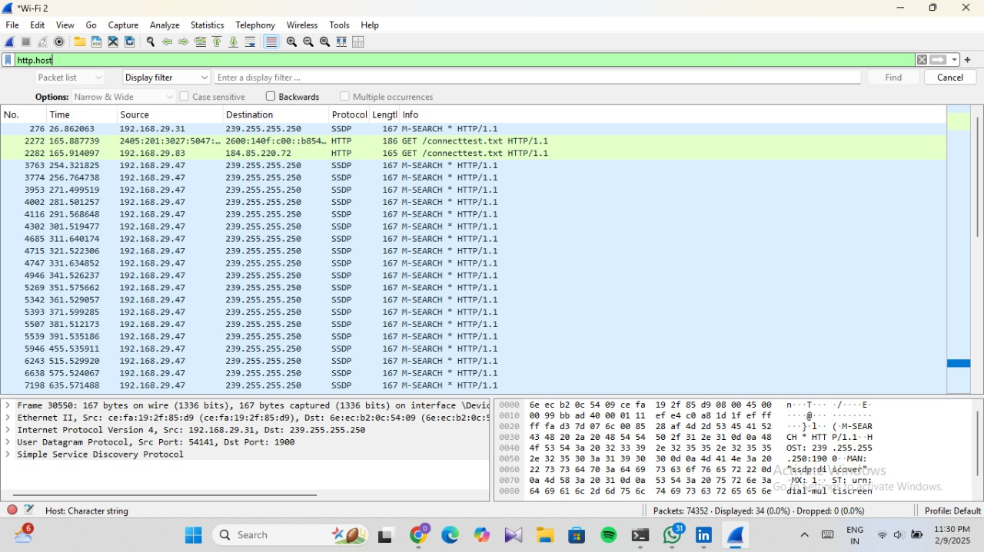

💡Identify HTTP Traffic using port 80:
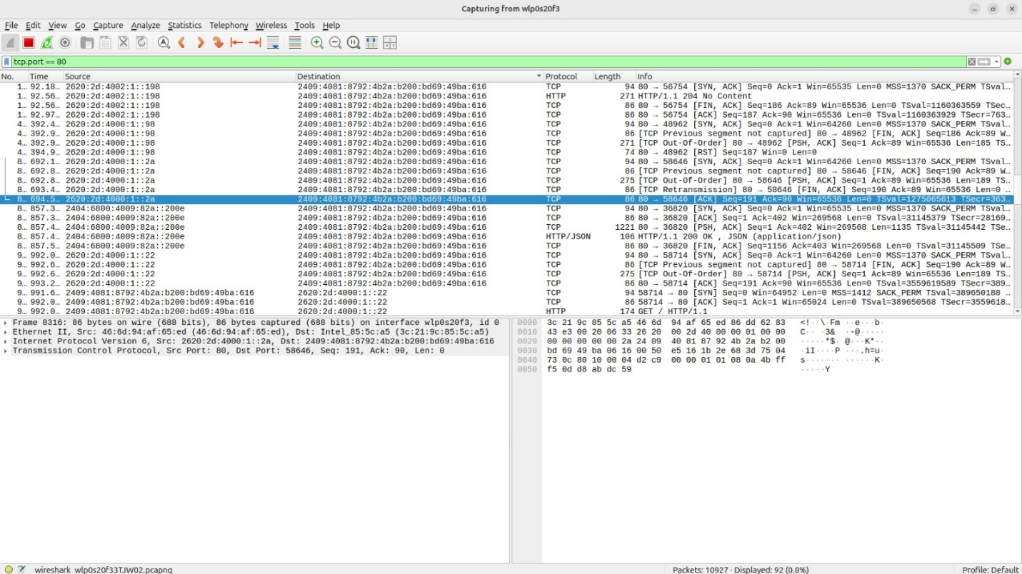
👉 Identify HTTPS TRAFFIC:
💡Using SSL filter:
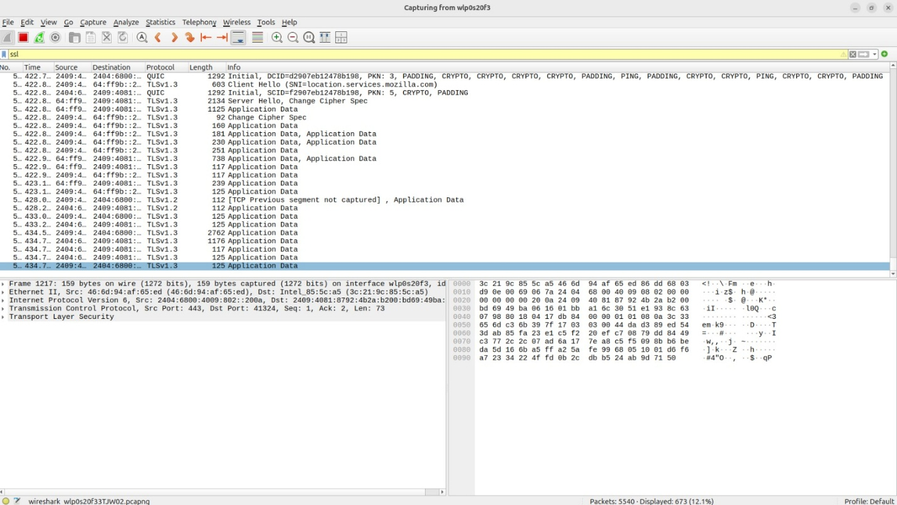
💡Using port 443:
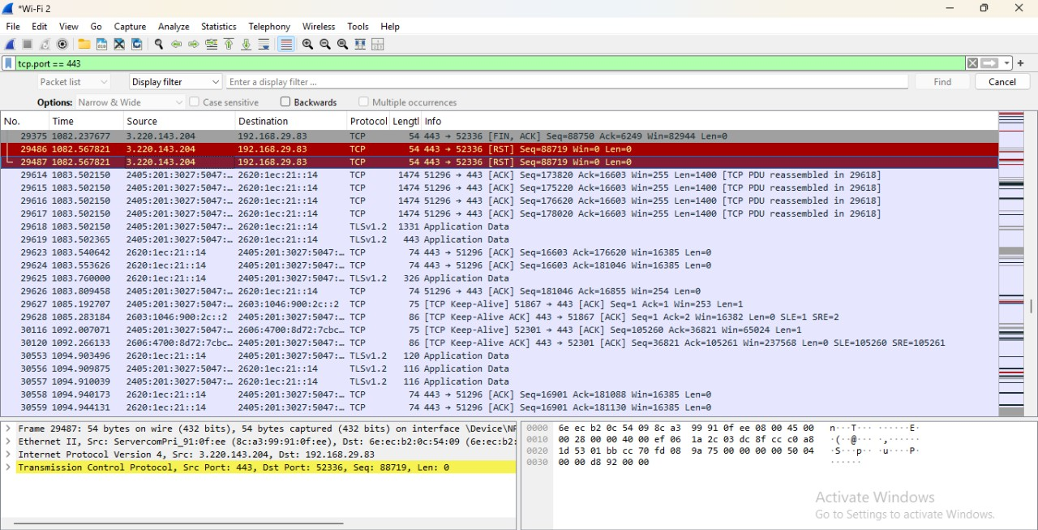
💡Using TLS filter:
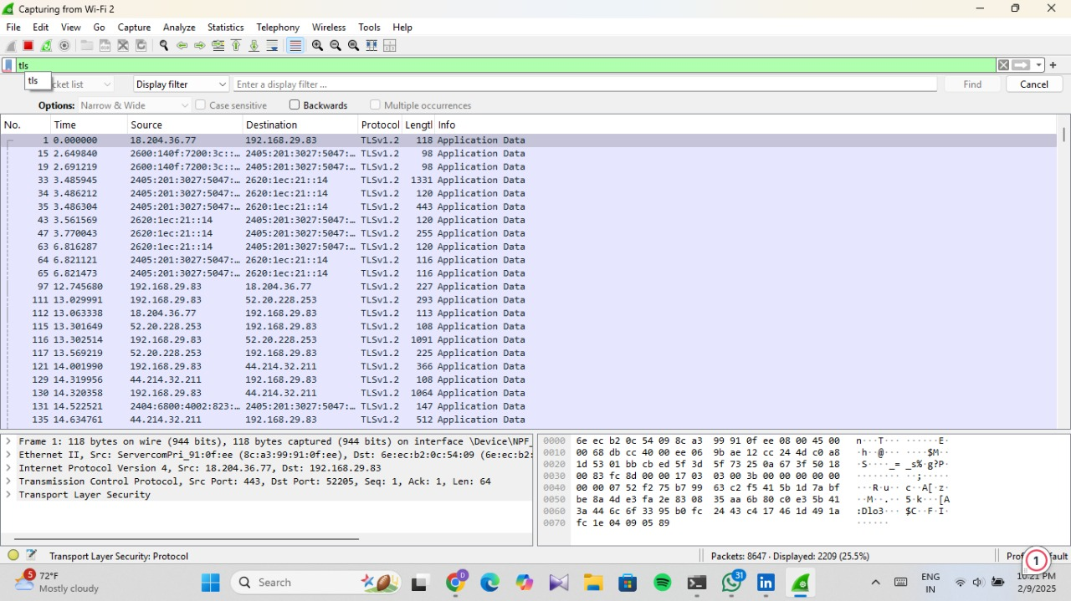
📌 Identify the IP address of a website you visit
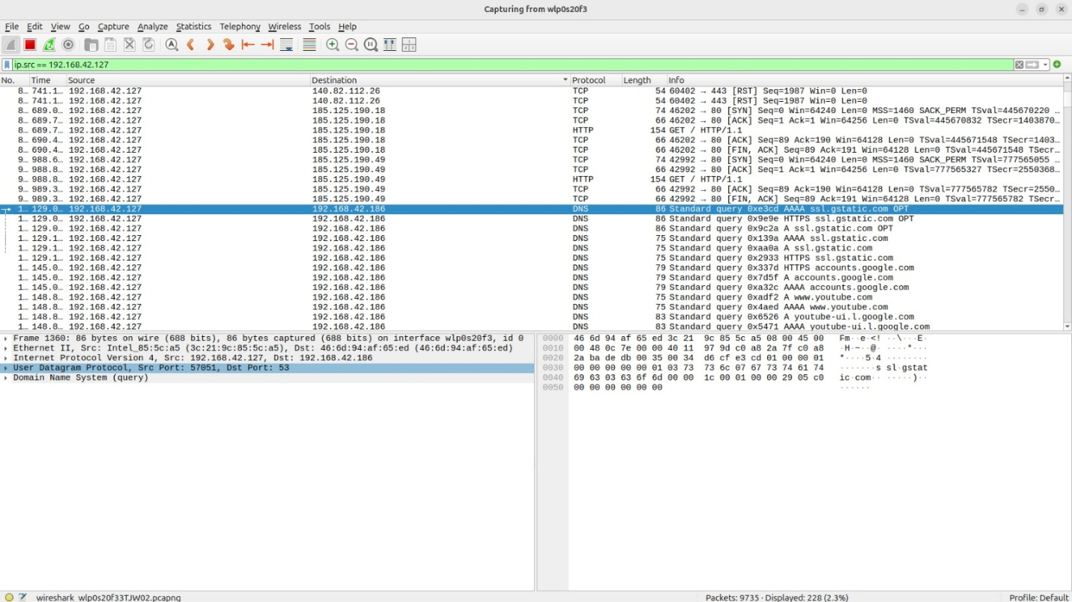

📌 Ping google.com:
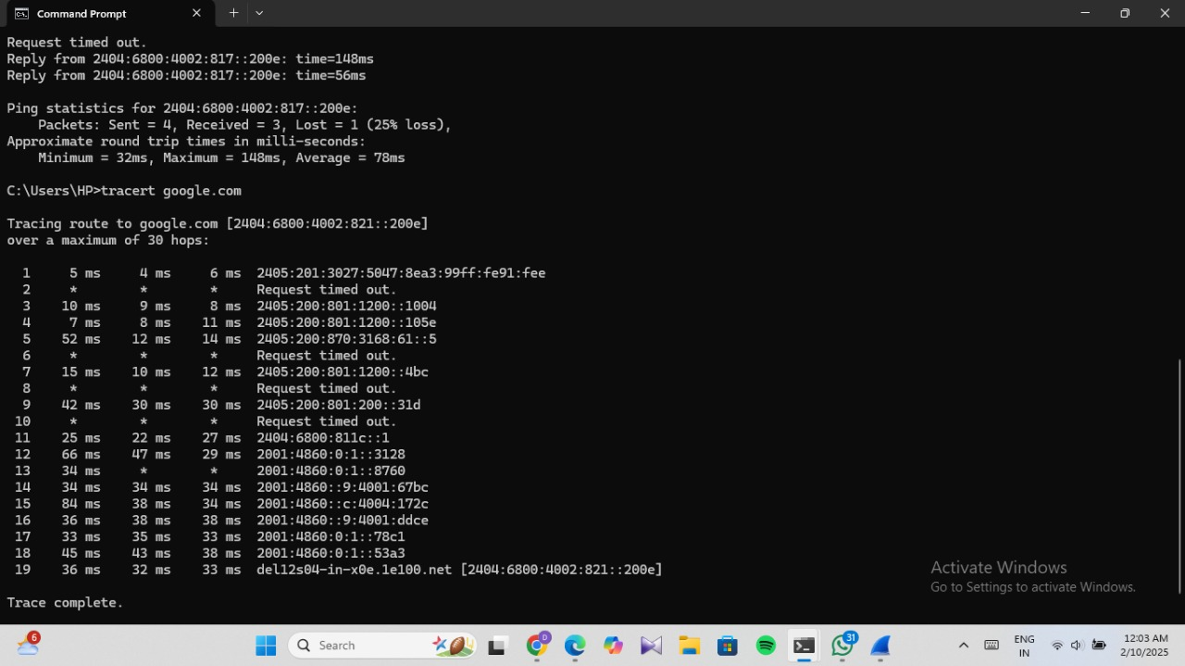
📌Traceoute google.com:
